**Associate Data Analyst in SQL DataCamp**

**Course 10: Understanding Data Visualization**

**Visualizing distributions**

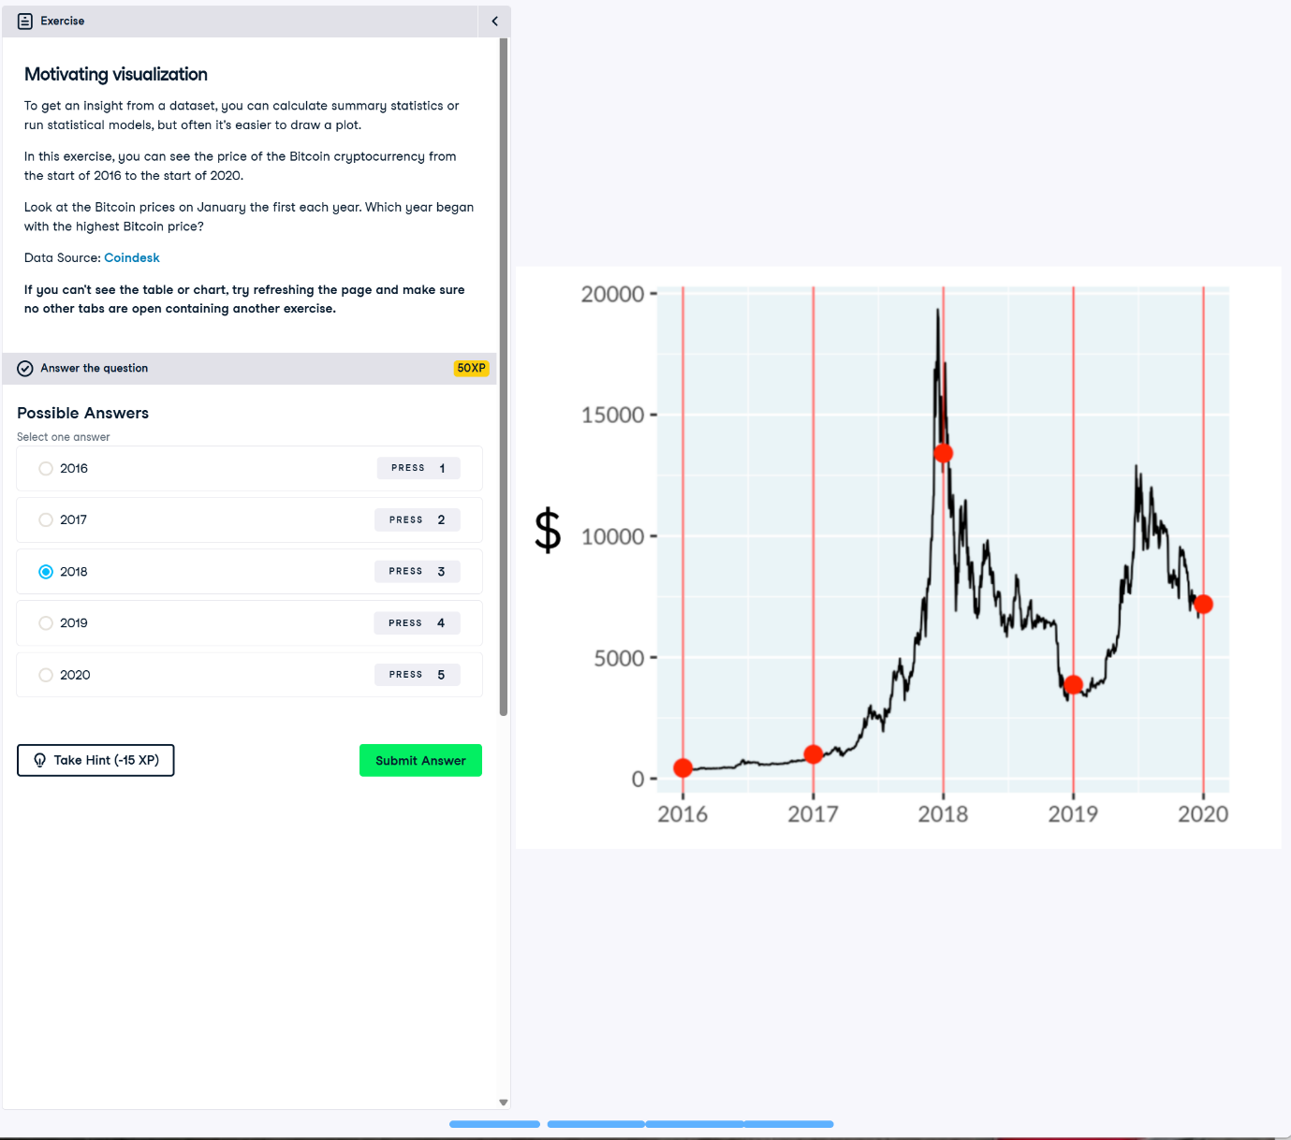

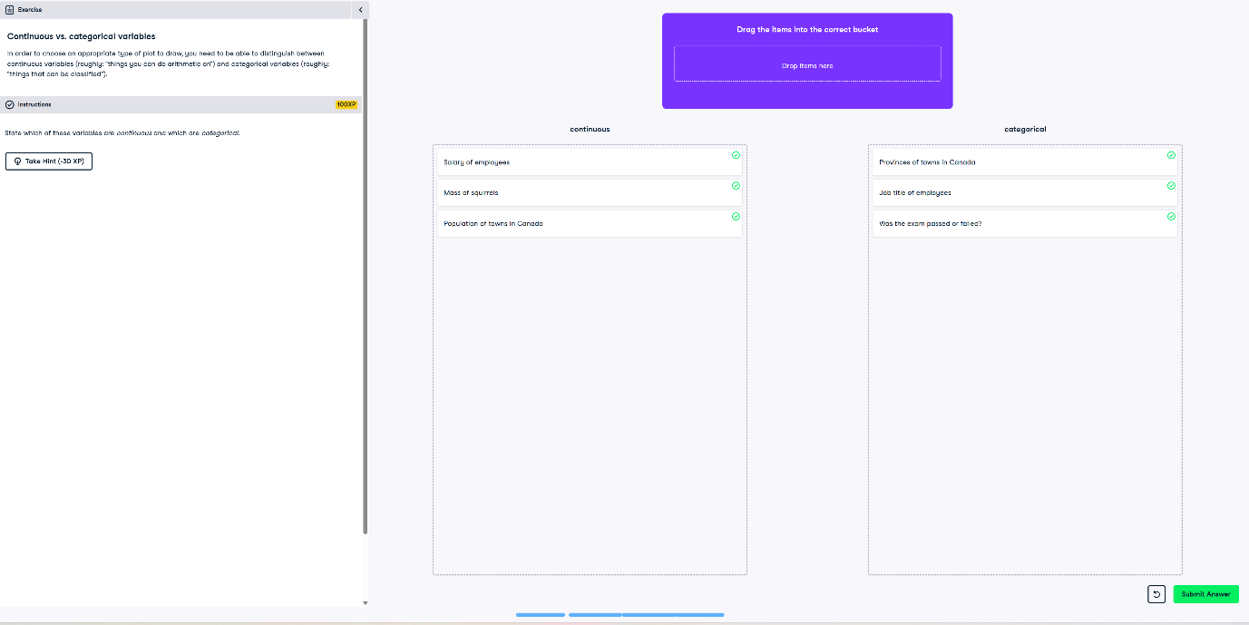

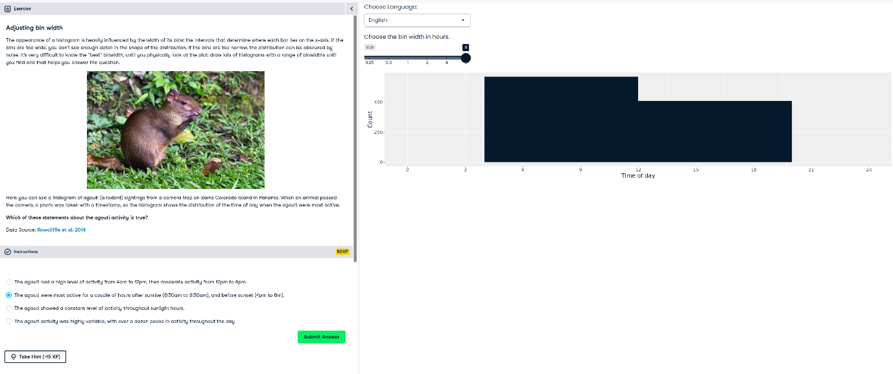

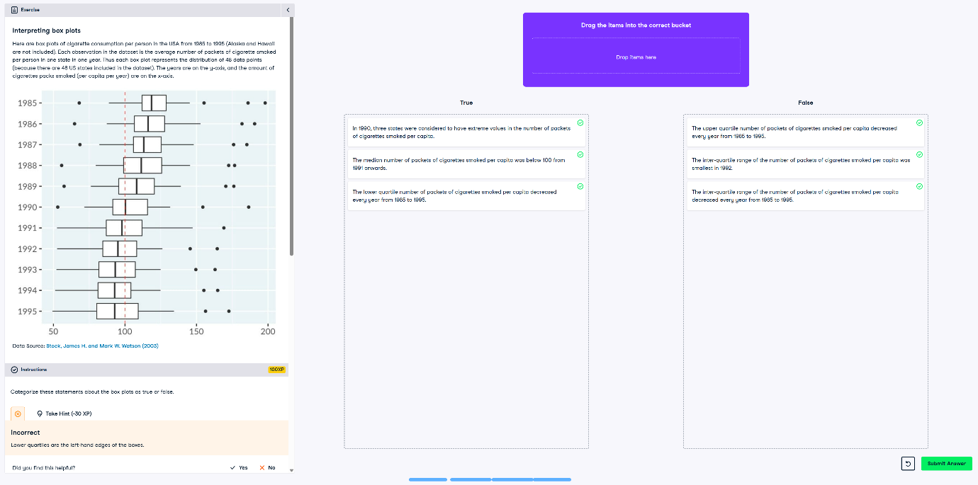

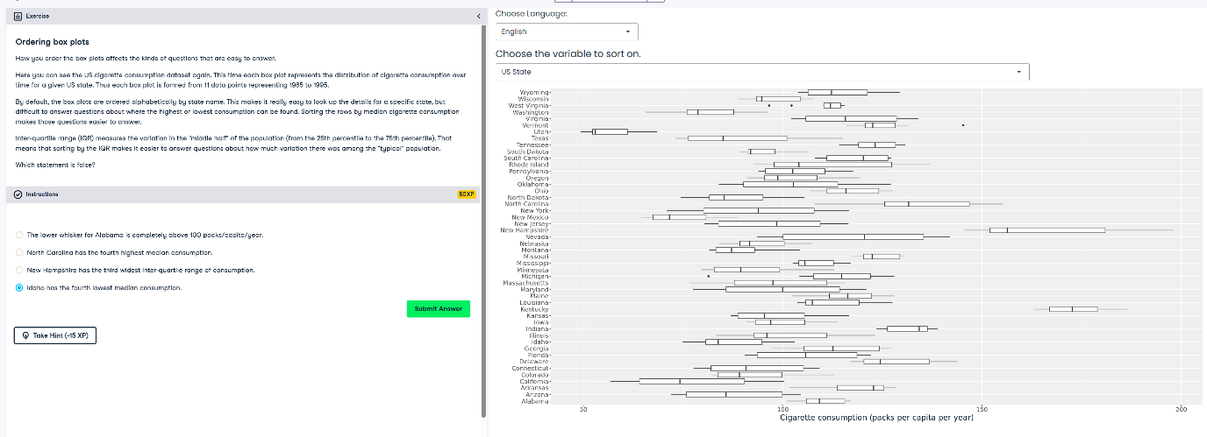

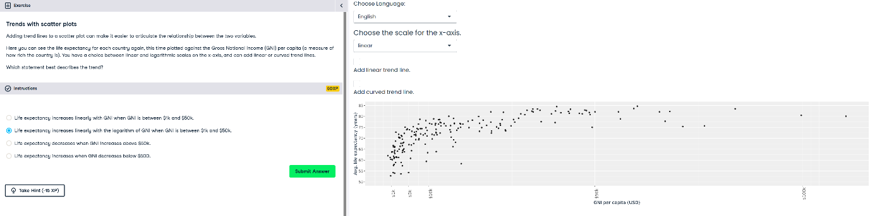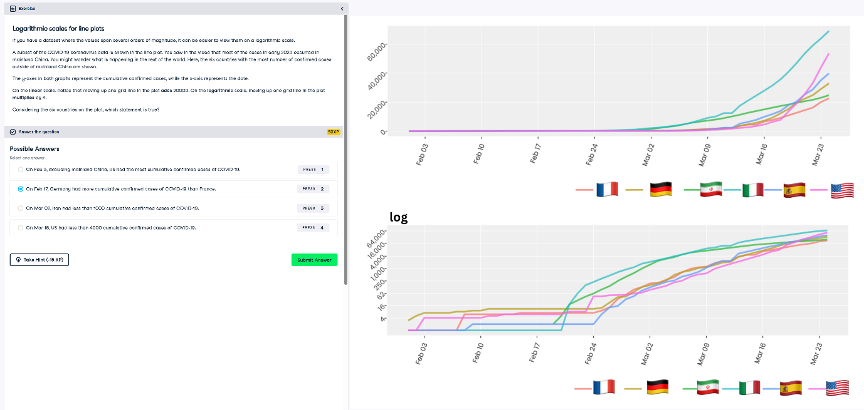

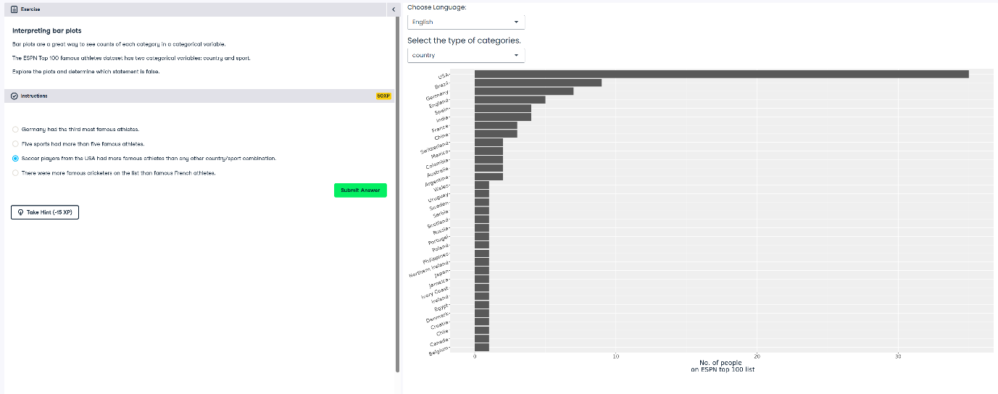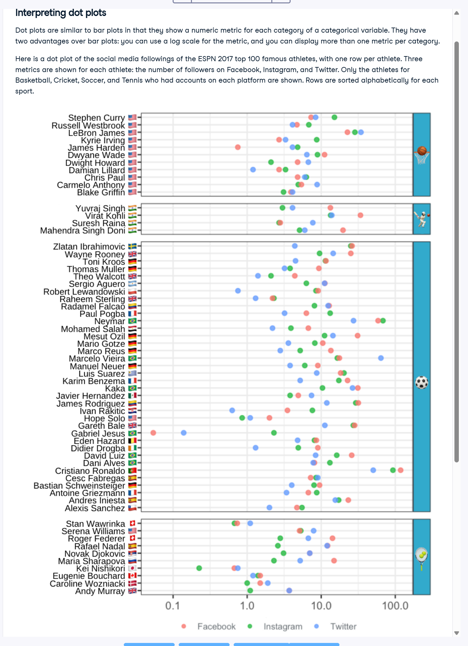

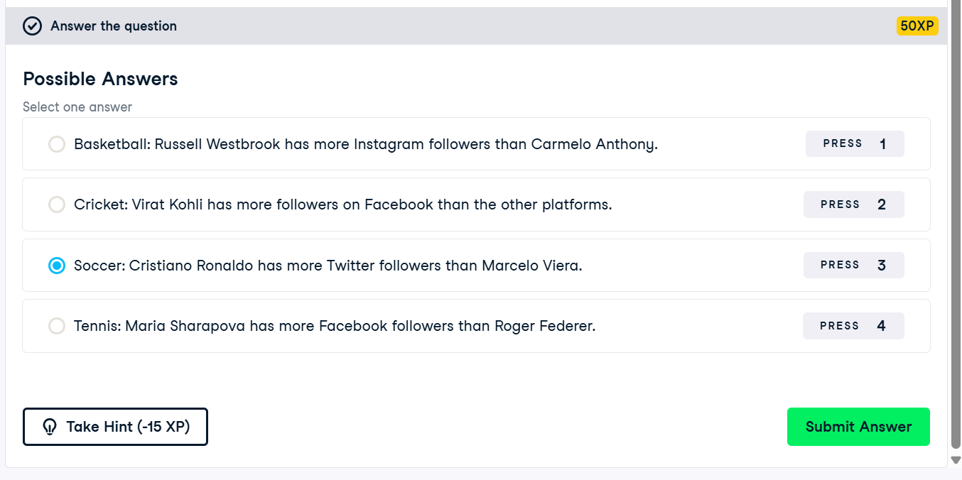

**The color and the shape**

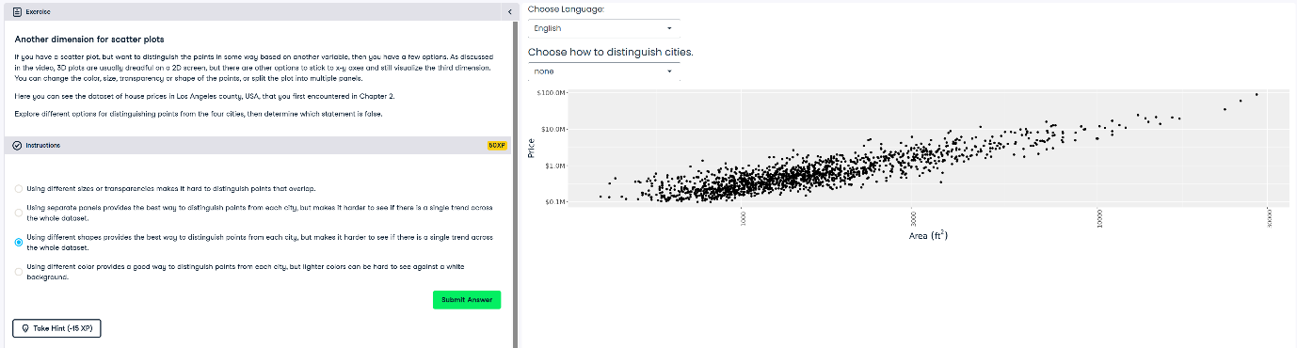

**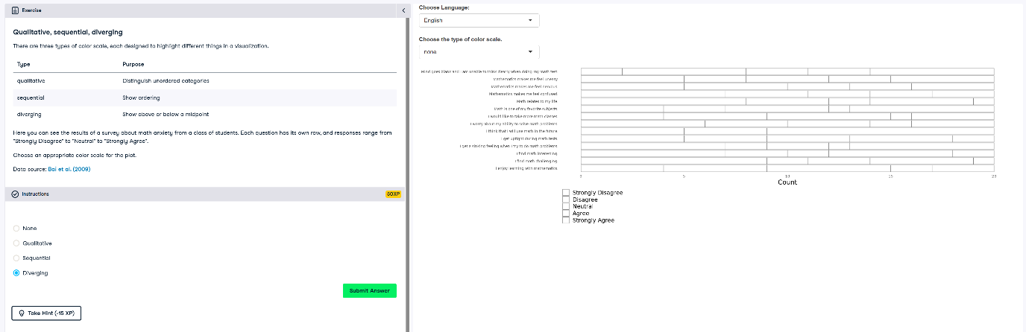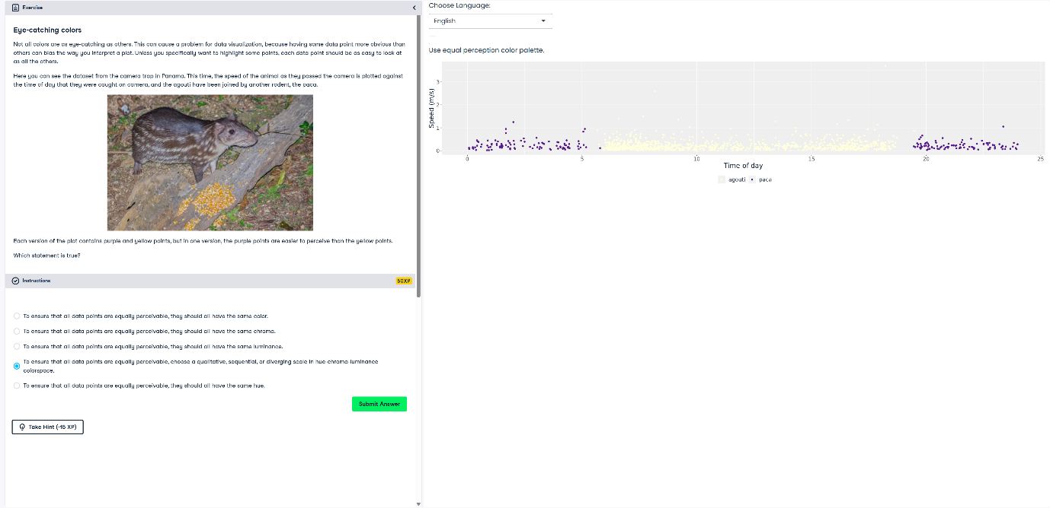  
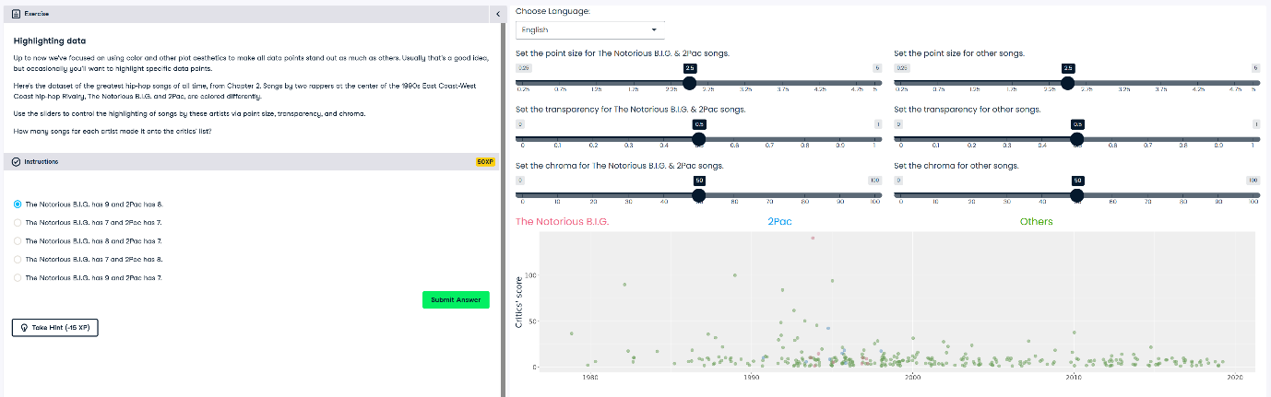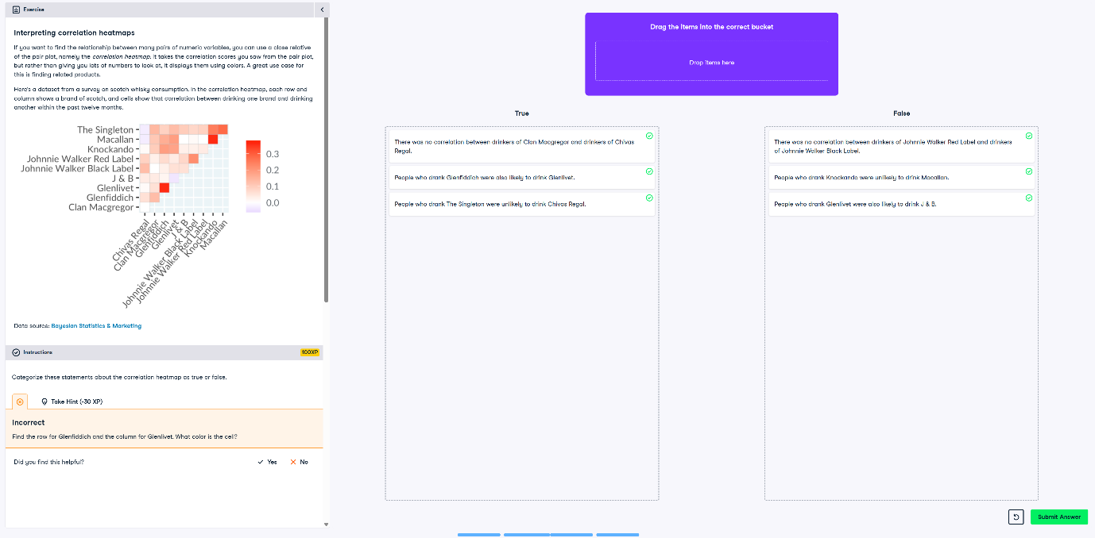**

**99 problem but a plot ain’t one of them**

